**EXCEL**

Course-End Project Problem Statement



**Designing a Sales dashboard in Excel**

Course-end Project 1

DESCRIPTION

Use Excel to analyze the sales based on various product categories.

**Description:**

The dataset in file **E-Commerce Dashboard dataset.xlsx** contains sales data for different product categories. The following are the features in the dataset:

|  |  |
| --- | --- |
| Order ID | Unique Order ID of a product |
| Order Date | Order Placement Date |
| Ship Date | Shipment Date of the placed order |
| Aging | Used to Create Histogram Bin |
| Ship Mode | Shipment mode of placed order |
| Product Category | Product Category |
| Product | Name of the Product |
| Sales | Sales Amount |
| Quantity | The amount or number of a material |
| Discount | A deduction from the usual cost of something |
| Profit | A financial advantage or benefit |
| Shipping Cost | The amount required to ship the placed order |
| Order Priority | Precedence of placed order |
| Customer ID | Unique Customer ID |
| Customer Name | Name of the Customer |
| City | Unique City Name |
| State | Unique State Name |
| Country | Unique Country Name |
| Region | Especially the part of a country |
| Months | The month of placing the order |

The following project tasks are required to be performed in Excel:

* Use the saved Sample E-Commerce database
* Prepare a table of Sales and Profit month-wise in a working sheet

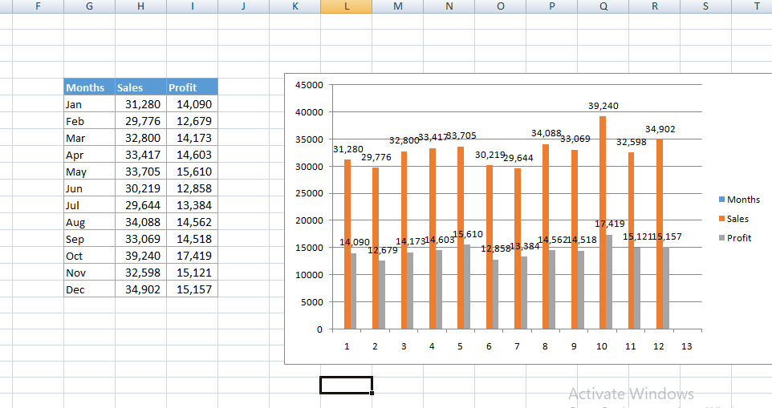

. Prepare the sales table region-wise in the working sheet

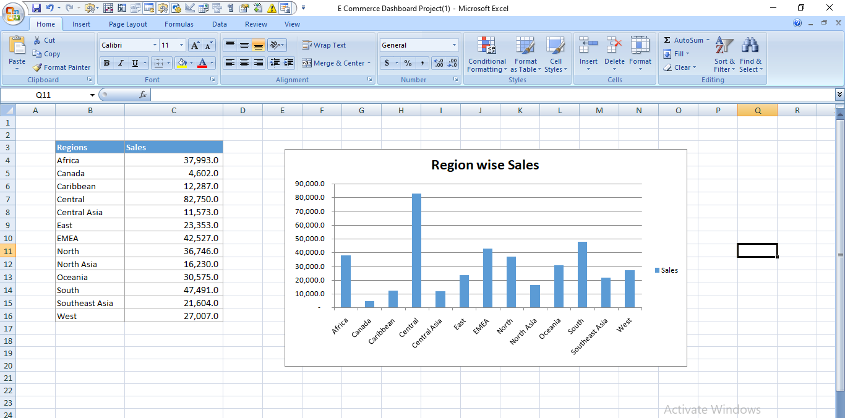

* Create User Control Combo box for Product Category

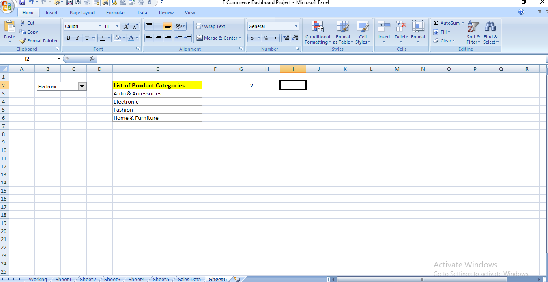

* Create a Column Chart of the month-wise table and region-wise table





* Link the table with a combo box

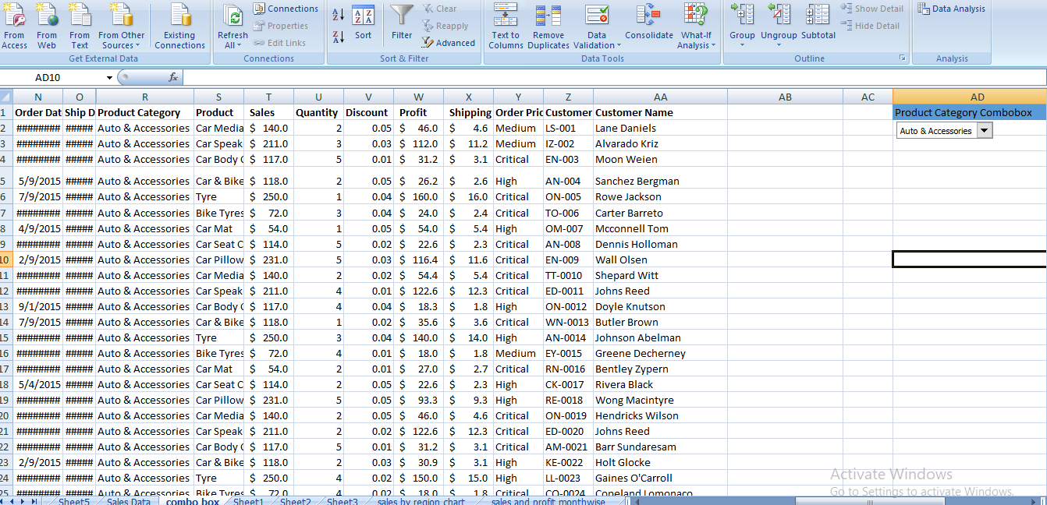

* Create a dashboar
* 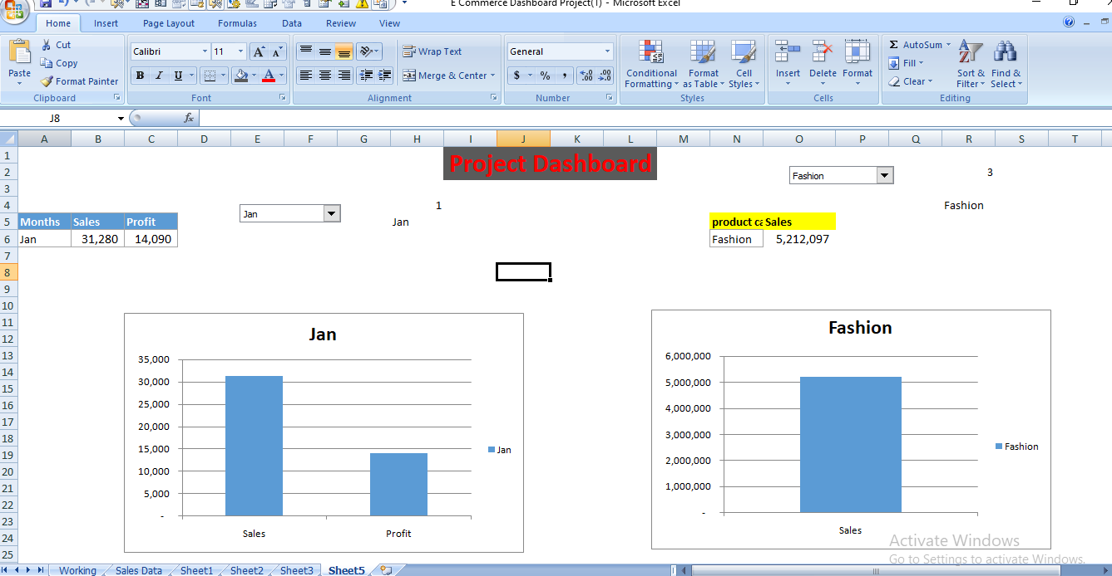

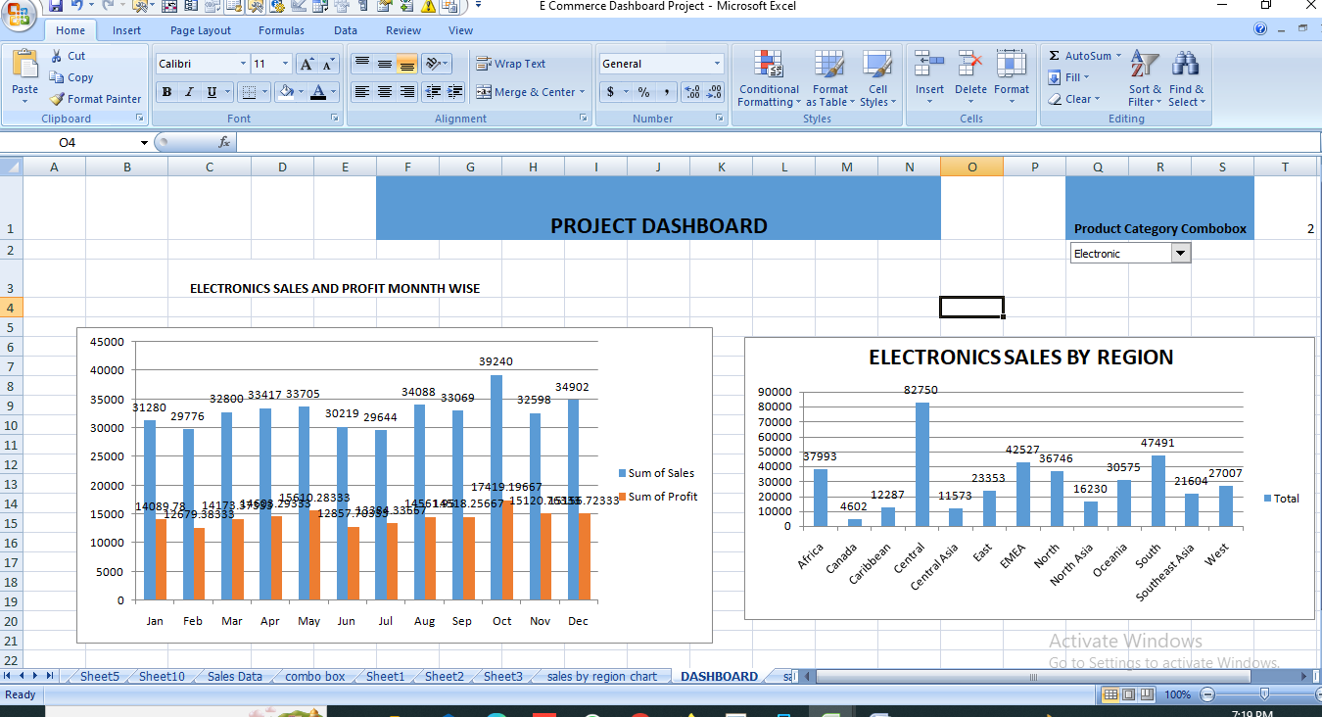

**Tools required:** Microsoft Excel, Data Analysis Add-in

**Expected Deliverables:** Design a sales dashboard that analyzes the sales based on various product categories. The company wants to add user control for product category so that users can select a category and can see the trend month-wise and product-wise accordingly.

